**Washoe County School District**

**SB 390 Zoom Schools Annual Report**

**Program and Services**

**School Year 2018-2019**

**May 20, 2020**

#### TABLE OF CONTENTS

Executive Summary 1

Introduction 7

Pre-Kindergarten (Pre-K) 8

Reading Skills Centers 11

Measures of Academic Progress (MAP) Reading Assessment Results - Elementary 13

Smarter Balanced Assessment Consortium (SBAC) 18

SBAC – ELA Zoom Elementary Schools 18

ACCESS Exit Rates for English Learners (EL) - Elementary 21

Nevada Growth Model (NGM) – English Learners’ AGP Performance - Elementary 22

Zoom Extended Day Leveled Literacy Intervention (LLI) Model for Grades K-3 23

Zoom Middle Schools 27

SBAC – ELA Zoom Middle Schools 28

ACCESS Exit Rates for English Learners (EL) – Middle School 29

Nevada Growth Model (NGM) – English Learners’ AGP Performance – Middle School 30

Corrective Action Schools 32

Professional Development 32

Recommendations from Washoe County School District 36

**Report Prepared by:**

Karen Perisho, Zoom School Coordinator

Norma Velasquez-Bryant, PhD, Program Evaluator

Kimberly Lynch, Grant Accountant

Lauren Ohlin, Director of Grants

# Executive Summary

In 2013 the Nevada Legislature enacted Senate Bill 504 which was aimed at improving the academic performance of English Learners. SB 504 specifically states, *“It is the intent of the Legislature that children who are limited English proficient be provided with services and instruction which is designed to address the academic needs of such children so that those children attain proficiency in the English language and improve their overall academic and linguistic achievement and proficiency.”* (NRS388.405). Through SB 504, NDE allocated money to school districts to provide specific programs and services to the lowest performing schools with the highest percentage of English Learners. These schools are known as Zoom schools, and the Senate Bill has continued through successive legislative cycles. The continuation of funding has allowed Nevada school districts to sustain programming and services implemented in an effort to continue to improve the academic and language achievement of English Learners.

As part of the 2017 Nevada Senate Bill 390, Washoe County School District (WCSD) maintained the 24 Zoom schools previously identified—19 district elementary schools, 1 district-sponsored charter elementary school, and 4 district middle schools. Across those 24 schools WCSD served 12,050 students, with 4,294 (36%) identified as EL in SY 2019.

In accordance with the requirements of the law, WCSD continued the implementation of a variety of programs and services aimed at helping to improve the academic and language achievement of English Learners. The main programs included:

*Pre-K Programs*: Early instruction and intervention is crucial to a child’s development, including their language and academic achievement. In alignment with the state performance goal to “Increase the percentage of students who enter Kindergarten ready to succeed…” WCSD has continued to offer pre-K services across the district. During SY 2019, WCSD provided Pre-K programming to 881 students across the district, with 550 (62%) of those students attending Pre-K at Zoom schools.

*Reading Skill Centers*: Access to high-quality, grade level instruction can help to accelerate both academic and linguistic achievement. Through the embedded reading skills center design in WCSD, students are engaged in high-quality, Tier 1 instruction that also focuses on increasing language proficiency. At the elementary level, reading skills centers engage students in daily, small group language and literacy instruction. In the middle schools, additional staff is hired to reduce class sizes in order to provide smaller group instruction in literacy and language.

*Extended Day Program, K-3*: WCSD Zoom elementary schools implemented an extended day model that provided Leveled Literacy Instruction (LLI) to students in grades K-3. This program focused on improving the reading proficiency of our earliest learners through a research-based program, teacher professional learning and instructional coaching. Students who participated in the program either arrived before or stayed after school to participate in the intense, 30-minute, small group instruction. MAP Growth Reading data for Extended Day were analyzed and results indicated that the Leveled Literacy Intervention (LLI) support provided to students before/after school did not result in any significant improvement in reading proficiency scores between Fall 2018 and Spring 2019. Using the results, WCSD determined that it was not cost-effective (N=292; $1,024/student) to continue this Extended Day model, and it was not implemented for the SY 2020.

*Middle School Extended Day*: Traner Middle School conducted intersession during school breaks that focused on both Math and ELA. This program had 24 students enrolled during winter intersession and 65 for spring intersession. Dilworth Middle School implemented an after-school extended studies program that provided additional instructional support and intervention to students identified through a combination of data review, teacher recommendation, and parent recommendation. Students were placed in the program for at least a unit of instruction (3-4 weeks), and often longer based on need. The program was fluid and served approximately 35 students each month. Sparks Middle School implemented a jump start summer program for incoming 6th grade EL students. This program familiarized students with the middle school setting, schedule, curriculum, and teachers. Vaughn Middle School implemented an after-school tutoring program. This program allowed students access to additional instruction and intervention as needed.

In conjunction with these main programs, WCSD has continued to include teacher professional learning (PL) and collaboration as part of the Zoom plan. A variety of opportunities provided teachers with learning and critical professional collaboration that allowed them to explore the link between language and learning, plan for high-quality language and content-based instruction, and continue to improve the fidelity of implementation of programs that best serve the students in WCSD.

Student achievement data across a variety of assessments continued to be monitored to measure the success of WCSD’s Zoom students. A summary of each assessment and results follows:

Brigance Early Childhood III Screens were used in the Pre-K program to screen students for readiness for learning: “Ready to Learn” ≥60th percentile. During the Fall 2018 - Spring 2019 approximately 538 Pre-K students were screened with an Average Score-Pre=84, and an Average Score-Post=88. All students met the Ready to Learn threshold.

During the SY 2017, Zoom schools received funding to implement Pre-K programs. Students who attended the Zoom Pre-K programs during this time, have been grouped as a cohort and various data are being monitored to assess student performance through Grade 3 in SY 2021. These will include MAP Growth Reading, ACCESS Exit Rates, and SBAC-ELA levels. Four Pre-K cohorts have been defined as follows for future comparison: The number of students who were designated as an EL in Grades 1-2 that attended Zoom Pre-K in SY17 (N=550): 2018-19 Grade 1=36 (7%); 2019-20 Grade 2=34 (6%); the number of students who were designated as an EL in Grades 1-2 that DID NOT attend a Zoom Pre-K in SY17 (N=331), but attended another Title 1, non-Zoom school: 2018-19 Grade 1=21 (6%); 2019-20 Grade 2=18 (5%); the number of students who were designated as an EL in Grades 1-2 that attended an external Pre-K program (non-District program) in SY17 (N=210): 2018-19 Grade 1=16 (8%); 2019-20 Grade 2=154 (73%); and the number of students who were designated as an EL in Grades 1-2 that did not attend a Pre-K in SY 2017 (note: attendance data were not reported): 2018-19 Grade 1=602; 2019-20 Grade 2=593.

The Nevada Department of Education mandated that Kindergarten program change the DRA assessment and replace it with Brigance Early Childhood Screens III for SY 2019. Approximately 4,700 kindergarten students were screened for placement purposes only. Nevada State Regulations also mandated MAP Growth Reading assessments for Kindergarten during Winter 2018 and Spring 2019 testing sessions. The MAP Growth Reading-ELA Proficiency level is defined as ≥40th percentile. Kindergarten results show that 16% (3 schools) had less than 20% of students that met proficiency; 11% (2 schools) had 20-29% of students that met proficiency; 32% (6 schools) had 30-39% of students that met proficiency; 26% (5 schools) had 40-49% of students that met proficiency; 5% (1 school) had 50-59% of students that met proficiency; 11% (2 schools) had 60-69% of students that met proficiency; and Overall Zoom Schools had an average of 37% of Kindergarten students that met proficiency compared to the Overall District at 55%. Additionally, a comparison of kindergarten EL students vs. Non-EL students at Zoom Schools, other Title 1 Non-Zoom schools, and WCSD indicate that EL kindergarten students are performing at approximately the same level as other Title 1 schools, and slightly less, 6.4%, than EL kindergarten students in the rest of the District.

Spring 2019 MAP Growth Reading for Grade 1 results show schools that met the 40th Percentile—Proficiency—as follows: 5% (1 school) had less than 20% of students that met proficiency; 21% (4 schools) had 20-29% of students that met proficiency; 32% (6 schools) had 30-39% of students that met proficiency; 26% (5 schools) had 40-49% of students that met proficiency; 16% (3 schools) had 50-59% of students that met proficiency; and Overall Zoom Schools had an average of 37% of Grade 1 students that met reading proficiency compared to the Overall District at 54%. A comparison of EL students vs. Non-EL students in Grade 1 at Zoom Schools, other Title 1 Non-Zoom schools, and WCSD indicate that EL Grade 1 students are performing slightly less (-1.8%) than other Title 1 schools, and less than (-7.1%) EL Grade 1 students in the rest of the district.

Spring 2019 MAP Growth Reading for Grade 2 results show schools that met the 40th Percentile—Proficiency—as follows: 0% (0 schools) had less than 20% of students that met proficiency; 11% (2 schools) had 20-29% of students that met proficiency; 32% (6 schools) had 30-39% of students that met proficiency; 47% (9 schools) had 40-49% of students that met proficiency; 11% (2 schools) had 50-59% of students that met proficiency; and Overall Zoom Schools had an average of 41% of Grade 2 students that met proficiency compared to the Overall District at 55%. A comparison of EL students vs. Non-EL students in Grade 2 at Zoom Schools, other Title 1 Non-Zoom schools, and WCSD indicate that EL Grade 2 students are performing slightly better (+1.3%) than other Title 1 schools, and less than (-5.2%) EL Grade 2 students in the rest of the district.

Grade 3 students were assessed using the SBAC-ELA. Results for Zoom school students showed no change in proficiency (Met AL Level 3 and 4), at 27% for both SY 2018 and SY 2019, with a slight increase (+3.0%) from SY 2017. Overall Zoom students had lower proficiency rates than similar Title 1 non-Zoom schools who experienced a slight decrease in Grade 3 proficiency from 2018 to 2019 (33% to 32%, respectively). Overall, students in WCSD decreased slightly from 45% to 44%, respectively, for SY18 and SY19. In Grade 3 there was no change for non-EL students=27% each year; and a decrease for EL students, from 17% to 14%.

Grade 8 students were also assessed using the SBAC-ELA. Results for Zoom school students showed and increase for non-EL students - 32% to 35%, SY 2018 to SY 2019, respectively; and no change for EL students at 5% each year.

The ACCESS (Assessing Comprehension and Communication in English State-to-State for English Learners) is an annual summative assessment of the developing social and academic English language proficiency for EL students in kindergarten through 12th grade. In SY 2017, NDE revised Exit criteria for exiting EL students from services to 4.5 overall.

Results indicate WCSD Zoom elementary schools showed a decrease of 3.1% in the total number of students exited between SY 2018 and SY 2019, from 14.9% to 11.8%, respectively. Zoom school students also exited at a lower rate than similar Title 1 non-Zoom schools in SY 2019—11.8% versus 13.0%, respectively. The overall results for WCSD elementary schools indicate a decrease between SY18 and SY19, from 15.0% to 10.8%, and a 1.0% decrease compared to Zoom schools. WCSD is also 2.2% lower than similar Title 1 non-Zoom schools, 10.8% versus 13.0%, respectively. This translates into a total of 427 students exited from services at Zoom elementary schools, 157 students at similar Title 1 non-Zoom elementary schools, and 1,075 students overall in WCSD elementary schools in SY19.

ACCESS Exit Rates for SY19 indicate that WCSD Zoom middle schools showed a slight increase in the total number of students exited between SY18 and SY19, from 6.3% to 6.7%. Additionally, Zoom middle schools exited at a higher rate than similar Title 1 non-Zoom schools did in SY 2019, 6.7% versus 2.5%. The results for WCSD middle schools overall show a very slight decrease of 0.1% between SY 2018 and SY 2019. This translates into a total of 52 students exited from services at Zoom middle schools, three students at similar Title 1 non-Zoom middle schools, and 103 students overall in WCSD middle school in SY 2019.

The Nevada Growth Model (NGM) measures student growth on state assessments compared to other students in the state with a similar score history. The Adequate Growth Percentile (AGP) on the ACCESS test is the Student Growth Percentile (SGP) an EL student needs to stay on track to reach a proficient level within five years or by grade 10. NDE has established recommended performance levels and outcome indicators for Zoom funded schools. It is important to note that the AGP is only one of several measures used to evaluate progress of EL students in the state. NDE recommended the AGP performance target for Zoom schools be set at the 50th percentile for all elementary schools with sufficient N-count of EL students (adopted by SBE June 2016).

The percentage of WCSD Zoom elementary school who met AGP on the SY 2019 ACCESS exam, showed 6 (30%) schools demonstrating positive growth; 3 (15%) schools with relatively flat growth; and 11 (55%) schools showing a decrease in AGP. However, a comparison between SY17 and SY19 shows that 15 (75%) of the Zoom elementary schools demonstrated an increase, and 5 (25%) demonstrated a decrease in AGP.

All four Zoom middle schools showed a decline in AGP between SY18 and SY19. However, a comparison of SY 2017 and SY 2019 shows that two (50%) middle schools demonstrated an increase, and two (50%) demonstrated a decrease in AGP.

The NSPF consists of a Star Rating based on various metrics, of which one is AGP. A comparison of star ratings for Zoom elementary schools between SY 2018 and SY 2019 show that 7 (35%) schools increased their rating, 11 (55%) maintained the same rating, and only 2 (10%) schools decreased by one star. A comparison of star ratings for Zoom middle schools between SY 2018 and SY 2019 show 2 schools maintaining their rating, and two schools increasing their star rating by one star.

**Conclusions**

These data indicate that there is still a critical need for continued focus on the progress and achievement of EL students in WCSD. To this end, WCSD will continue to focus on high-quality, grade-level Tier 1 instruction that includes intentional language learning strategies and supports. Evidence-based interventions will continue to be used to accelerate the growth of students that are not at grade-level, and professional learning will continue to be implemented to build the capacity of all educators in WCSD around the language and content needs of English Learners.

**Recommendations:**

The Zoom School initiative has enabled WCSD to reconsider and restructure thinking and practice regarding the appropriation of new models for growth, as well as modes of teaching and learning to support EL students. The major investments must focus on strengthening the collective capacity of teachers, school administrators, and district leaders to create conditions for improved instructional practice and student achievement.

WCSD Zoom schools will maintain uninterrupted programming and services as a result of legislators’ decision to *continue* Zoom funding for the next biennium, 2019-2021. The program impact will allow sustained support through SY 2020 and SY 2021 for all 24 Zoom schools. Zoom funding will provide WCSD the resources and opportunity to continue critical programming.

WCSD recommends continued funding for the following:

1. Certified teachers and classified staff in order to reduce class size and provide students with the high-quality, targeted EL and literacy instruction that they need.
2. Professional learning for teachers to ensure that EL, literacy and intervention instruction is delivered to the highest degree possible.
3. Intersession and/or extended day programs to provide students additional instructional time outside of the regular school day and to work with existing afterschool programs such as 21st Century Community Learning Centers in order to maximize efficiency (teachers’ availability) and not compete with other after school programs to ensure student attendance.
4. Pre-K programs to strengthen kindergarten readiness.
5. Critical resources to enhance EL, literacy and intervention instruction and programs (e.g. Reading Skills Centers, ELLevation).

Finally, WCSD recommends the elimination of the 5%spending cap. This would allow all Zoom-funded LEAs the flexibility and ability to better support schools through high-quality teacher professional development opportunities. LEAs would also be able to explore potential strategy development of effective teacher recruitment and retention incentives, and potential increases in family engagement activities leading to successful language acquisition growth for all Zoom school students.

# Introduction – WCSD Zoom School Programming

SB 390 funds supported programming in 24 schools (20 elementary and four middle schools) during SY 2018-2019 to implement key initiatives mandated by the Legislature:

1. Pre-K Program-critical early literacy skill development;
2. Reading Skills Centers-daily responsive small group literacy instruction; and
3. Extended Day Program-Leveled Literacy Intervention (LLI) program for struggling readers.

Although WCSD elected to use funds primarily for professional learning in lieu of family engagement, schools were able to leverage other funds and resources to support Zoom schools with family engagement**,** working successfully with families through a variety of programs and structures:

* Parent Involvement Facilitator (PIF) - All Zoom schools
* Family Engagement Plan - All Zoom schools
* Parent Teacher Home Visit Project-14 Zoom schools
* Academic Parent Teacher Teams (APTT)-3 Zoom schools
* Parent University -12 Zoom schools

Table 1 presents the 24 Zoom schools by *Funding Year*. Also shown are the *Actual Funds Used* by each school for SY 2018 and SY 2019. Student enrollment totals (minus Pre-K) are shown, along with the percent of EL students at each Zoom school. These figures are based on official *Count Day* numbers.

**Table 1. WCSD Zoom Schools—SB 390 Funding SY 2018 and SY 2019 (No Pre-K)**

| Original Funding Year | School Name | $ Actual Funds Used  SY 2018 | $ Actual Funds Used  SY 2019 | Enrollment Count-Day  SY 2019 | % EL  SY 2019 |
| --- | --- | --- | --- | --- | --- |
| 2013-2014 | Anderson ES | 230,155 | 263,332 | 455 | 34.1  (n=155) |
|  | Corbett ES | 194,078 | 300,767 | 511 | 51.4  (n=267) |
|  | Duncan ES | 224,319 | 222,696 | 397 | 46.2  (n=190) |
|  | Loder ES | 147,100 | 239,651 | 542 | 50.7  (n=275) |
|  | Mathews ES | 172,513 | 233,687 | 536 | 47.5  (n=258) |
|  | Veterans ES | 213,094 | 272,792 | 422 | 36.3  (n=153) |
| 2014-2015 | Cannan ES | 239,383 | 354,128 | 493 | 33.3  (n=164) |
|  | Sun Valley ES | 247,770 | 342,731 | 651 | 47.2  (n=307) |
| 2015-2016 | Kate Smith ES | 132,081 | 223,291 | 308 | 52.3  (n=161) |
|  | Lemelson ES | 235,370 | 320,086 | 363 | 28.8  (109) |
|  | Lincoln Park ES | 149,612 | 195,007 | 346 | 30.3  (n=112) |
|  | Allen ES | 160,285 | 297,411 | 510 | 35.5  (n=188) |
|  | Mariposa ES | 214,735 | 274,903 | 178 | 53.0  (n=94) |
|  | Mitchell ES | 179,371 | 214,970 | 359 | 28.5  (n=103) |
|  | Traner MS | 414,209 | 533,811 | 781 | 32.9  (n=257) |
| 2016-2017 | Bennett ES | 235,451 | 257,207 | 490 | 27.0  (n=141) |
|  | Greenbrae ES | 174,633 | 276,853 | 368 | 41.0  (n=151) |
|  | Maxwell ES | 263,528 | 306,877 | 492 | 27.4  (n=140) |
|  | Palmer ES | 267,528 | 324,233 | 501 | 31.2  (n=157) |
|  | Risley ES | 254,038 | 350,945 | 477 | 39.2  (n=187) |
|  | Smithridge | 159,714 | 191,481 | 617 | 44.9  (n=289) |
|  | Dilworth MS | 328,563 | 397,226 | 712 | 21.8  (n=155) |
|  | Sparks MS | 572,210 | 666,313 | 769 | 27.4  (n=211) |
|  | Vaughn MS | 315,350 | 275,718 | 602 | 27.2  (n=164) |
| TOTAL: | 24 Zoom Schools | $5,680,091 | $7,336,115 | 11,186 | 36.6% |

Zoom schools play a critical part in supporting *Nevada’s SB391 Read by Grade Three,* legislation designed to ensure all students will be able to read proficiently by the end of Grade 3. Below are descriptions and highlights of the Zoom program structure and design, including program costs, number of students receiving services, cost-per-student, evidence of program successes, and data sources used to monitor effectiveness and for ongoing Zoom program evaluation.

# WCSD Zoom Pre-Kindergarten (Pre-K)

During SY 2019, Pre-K programs served approximately 881 students in the District, and 550 students at 19 Zoom schools. The program structure was either full-day or half-day, four days per week. Pre-K students gained important school readiness skills through high quality Pre-K programming that incorporated curricula based on the Nevada Pre-K Content Standards. Pre-K classrooms used learning centers that promoted pre-reading and writing skills, math, movement, music, language, literacy, science, art, self-help skills, and socialization. This type of learning environment and curriculum provided Pre-K students with the foundational skills necessary to make a successful transition to kindergarten. The program is evaluated using District-approved language assessments and the Brigance Early Childhood III Screens

The estimated *Cost-Per-Student* of Pre-K programming in SY 2017, SY2018 and S Y2019 is reported in Table 2.

**Table 2. WCSD Cost-Per-Student of Pre-K Programming, SY 2017, SY 2018, SY 2019**

| School Year | Total Cost of Pre-K | Number of Pre-K Students Served | Cost-Per-Student |
| --- | --- | --- | --- |
| 2016 – 2017 | $987,400 | 714 | $1,383 |
| 2017—2018 | $807,705 | 770 | $1,049 |
| 2018—2019 | $933,889 | 881 | $1,060 |

# Results of Pre-K Brigance Early Childhood Screens III

WCSD administered the Brigance Early Childhood Screens II assessment for Pre-K students at Zoom schools, which replaced the prior Pre-K WIDA Oral Proficiency assessment. Results are shown in Figure 1, and all students met the ≥60th percentile, “Ready to Learn” benchmark. Note: WCSD does not assess students as EL until Kindergarten.

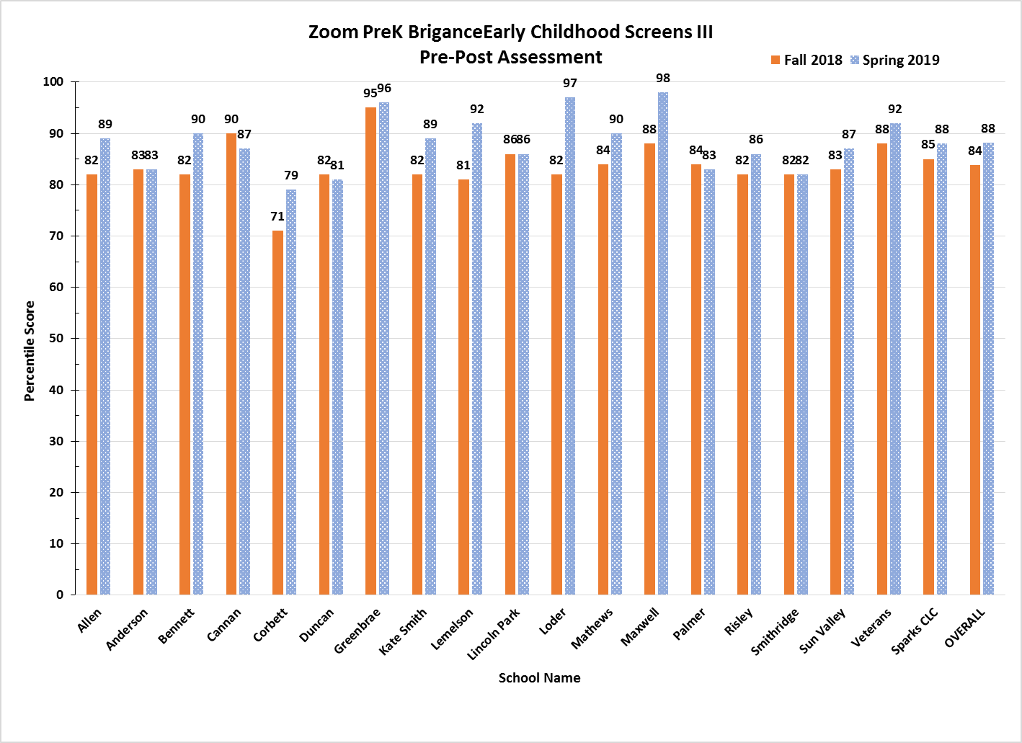

**Figure 1. Pre-K Brigance Early Childhood Screens III Pre/Post Results, SY 2019**

**Pre-K EL Students**

During the SY 2017, Zoom schools received funding to implement Pre-K programs. Students who attended the Zoom Pre-K programs during this time, have been grouped as a cohort and various data are being monitored to assess student performance through Grade 3 in SY 2021. These will include MAP Growth Reading, ACCESS Exit Rate, and SBAC-ELA levels. Four Pre-K cohorts have been defined as follows for future comparison:

* Number of students who were designated as an EL in Grades 1-2 that attended Zoom Pre-K in SY17 (N=550): 2018-19 Grade 1=36 (7%); 2019-20 Grade 2=34 (6%)
* Number of students who were designated as an EL in Grades 1-2 that DID NOT attend a Zoom Pre-K in SY17 (N=331), but attended another Title 1, non-Zoom school: 2018-19 Grade 1=21 (6%); 2019-20 Grade 2=18 (5%)
* Number of students who were designated as an EL in Grades 1-2 that attended an *external Pre-K program (non-District program) in SY17 (N=210): 2018-19 Grade 1=16 (8%); 2019-20 Grade 2=154 (73%)
* Students who were designated as an EL in Grades 1-2 that did not attend a Pre-K in SY 2017 (note: attendance data were not reported): 2018-19 Grade 1=602; 2019-20 Grade 2=593

*[*External Pre-K providers included Friends/Family/Neighbor Care; Head Start; Home-Based /Family Care Center (child care provided by someone else); Provided by a Private Child Care Facility or Other Daycare Center; and Provided by or at the University or College Campus.]*

# Zoom Reading Skills Centers

During SY 2019, Zoom schools continued implementation of an embedded Reading Skills Center model. The Reading Skills Centers were embedded in the regular classroom where students received daily responsive small group instruction (e.g., Guided Reading) as part of comprehensive literacy instruction built into the school’s regular instructional day. The Reading Skills Centers provided all students access to high quality Tier 1 instruction, while also receiving small group instruction. Daily, students participated in literacy instruction with time for small-group and intensive instruction in the five essential literacy elements (1) phonological awareness, (2) phonemic awareness, (3) decoding skills, (4) reading fluency, and (5) comprehension.

The Reading Skills Centers also provided targeted intervention using ESSA evidenced-based literacy curriculum resources (Leveled Literacy Intervention and Phonics First), and additional staff, such as Teaching Assistants, who collaborated with teachers in planning and facilitating small group intervention. In addition, four Zoom School Facilitators continued to monitor, provide training and ongoing technical support to teachers and teacher assistants to strengthen language and literacy instruction and intervention across all Zoom schools.

## Tiered Interventions, Monitoring, and Targeted Support:

Using the Multi-Tiered System of Support (MTSS) framework, WCSD implements ESSA Tiers 1-3 interventions for students identified with a reading deficiency. WCSD began intensive professional learning with select K-3 teachers in SY 2017 and continued in SY 2019 in how to use these literacy intervention programs with fidelity. The professional learning provided additional teachers the skills necessary to be responsive and adaptive in literacy intervention instruction in Guided Reading, Leveled Literacy Intervention (LLI), and Phonics First®. Zoom schools continue to use these programs and materials as part of the Reading Skills Center to make a systemic change in implementing early literacy interventions for all K-3 students, with an emphasis on English Learners.

All K-3 students who were identified as “deficient” in reading in SY 2019 were provided access to a three-tiered system of intervention monitoring and support to ensure they made gains in language acquisition and reading proficiency. Each student had a reading plan that outlined the intervention instruction and progress monitoring they received.

**Tier 1**: Students with a Tier 1 plan received monthly progress monitoring using aimswebPlus Early Literacy and/or Oral Reading Fluency and/or common classroom assessments. Tier 1 Reading Plans were embedded in comprehensive literacy instruction using a variety of methods.

**Tier 2:** Biweekly progress monitoring using the Aimsweb Plus Early Literacy measures and/or Oral Reading Fluency were conducted for these students. These data were used to monitor individual growth in response to the intervention. To evaluate Tier 2 services, school teams examined student growth and the implementation fidelity of the intervention plan. The Tier 2 Intervention Plans supplemented Tier 1 instruction and involved an additional 90-135 minutes of instruction each week (e.g., two 45-minute intervention periods). Tier 2 interventions were more explicit; more intensive than Tier 1 instruction; more supportive in the form of encouragement, feedback, and positive reinforcement; with scaffolding; and occurred in groups of approximately three to six students. These interventions may have included LLI or Phonics First®.

**Tier 3:** Weekly progress monitoring using the AimsWeb Plus Early Literacy measures and/or Oral Reading Fluency were conducted for students in Tier 3. Students received differentiated Tier 1 instruction plus Tier 3 *intervention*, which was intensive, supplemental instruction in a small group individualized to the student’s needs based on the individual problem-solving process. Interventions may have included LLI or Phonics First®.

### **Guided Reading and Language Acquisition:**

**Guided Reading** is used throughout all WCSD’s elementary schools as part of balanced literacy instruction. Guided Reading is designed to provide small group differentiated instruction to support students’ individual needs in developing reading proficiency in all five essential literacy elements**.**

**Guided Language Acquisition and Design (GLAD):** GLAD promotes instructional practices addressing the development of English language while providing students with strategies to increase reading comprehension in any content area, student interaction, higher order thinking, and use of learning strategies. WCSD’s Department of English Language Development uses an innovative strategy for intersession or afterschool tutoring times by having both students receive instruction and teachers receive PL. The five-day GLAD Demonstration uses one GLAD trainer to teach students modeling GLAD strategies through a standards-based thematic unit. The other GLAD trainer coaches the teachers who observe the class. Follow-up PL includes modeling GLAD strategies for PLC teams and individual teachers. Some Zoom schools have engaged in this professional learning and implementation of GLAD, but not all.

WCSDs unique embedded reading skills center design ensures that all students across the district, regardless of school funding, labels or other factors, receive equitable access to the instruction and additional support (s) they need to reach both language and academic proficiency. Due to the nature of the design, it is difficult to report on the number of students who “passed through” a reading skills center. Instead, this design is fluid and meets the needs of students as they arise. The support is daily and embedded. The program was evaluated using the MAP Growth Reading assessment K-3, SBAC-ELA assessment for Grades 3-6, and ACCESS (EL Exit Rate) assessment for K-6. Additionally, administrators and Zoom School Facilitators used classroom observation evidence throughout the school year to monitor and evaluate literacy instruction, which provided school leaders with data on the consistency and quality of Guided Reading and LLI implementation. These data were used throughout the school year to identify areas for improvement and to provide feedback on key literacy components as part of an effective guided reading lesson (e.g., selecting an appropriate level text, introducing the text, students reading and problem-solving with text, and checks for understanding) or LLI intervention lesson to teachers and teacher assistants.

The *Cost-Per-Student* to operate the Reading Skills Centers for SY 2018, and SY 2019 are reported in Table 3. Data are pending for SY 2020 and will be updated at the end of fiscal year 2020.

**Table 3. WCSD Zoom Schools, Reading Skills Centers: Cost-Per-Student**

**SY 2018, SY 2019**

| Funded School Year | Total Cost of Reading Skills Centers | Number of  Students Served | Cost-Per-Student |
| --- | --- | --- | --- |
| 2017—2018 | $4,393,493 | 12,289 | $357 |
| 2018—2019 | $5,800,657 | 12,050 | $482 |

# 

# Reading Skills Center Program Successes

* The data in the next sections will outline the impact of the reading skills center in the Zoom schools as compared to other Title I schools as well as WCSD as a whole.
* WCSD continued to provide additional literacy curriculum, instruction, and assessment resources, such as computer technology, leveled readers, EL materials, and literacy intervention resources for teachers to support EL and literacy instruction in classrooms.
* Additional Zoom certified teachers and teaching assistants were able to reduce class sizes in order to provide students with more individualized EL, literacy, and intervention instruction.

# Measures of Academic Progress (MAP) Growth Reading Assessment:

# Elementary Schools, K-3

# Kindergarten Results

The Kindergarten program state mandates changed with DRA assessments replaced with Brigance Early Childhood Screens III for SY 2019, and approximately 4,700 kindergarten students were screened for placement purposes only. Nevada State Regulations also mandated MAP Growth Reading assessments for Kindergarten during Winter 2018 and Spring 2019 testing sessions.

The Spring 2019 MAP Growth Reading results for overall Kindergarten students are shown in Table 4. Results show Zoom schools that met the 40th Percentile—Proficiency—as follows (note—data were not available for Mariposa Charter; totals may not equal 100% due to rounding):

* 16% (3 schools) had less than 20% of students that met proficiency
* 11% (2 schools) had 20-29% of students that met proficiency
* 32% (6 schools) had 30-39% of students that met proficiency
* 26% (5 schools) had 40-49% of students that met proficiency
* 5% (1 school) had 50-59% of students that met proficiency
* 11% (2 schools) had 60-69% of students that met proficiency
* Overall Zoom Schools had an average of 37% of Kindergarten students that met proficiency compared to the Overall District at 55%

**Table 4. Percent of Kindergarten Students Meeting 40th Percentile MAP Growth Reading, Spring 2019**

| **Elementary School Name** | **Kindergarten, Spring 2019**  **% Met 40th Percentile**  **MAP Growth Reading** |
| --- | --- |
| Anderson | 52.5 |
| Corbett | 19.7 |
| Duncan | 23.7 |
| Loder | 16.2 |
| Mathews | 45.1 |
| Veterans | 33.3 |
| Cannan | 28.9 |
| Sun Valley | 30.6 |
| K. Smith | 18.5 |
| Lemelson | 35.7 |
| Lincoln Park | 44.6 |
| Allen | 41.5 |
| Mariposa Charter | NA |
| Mitchell | 36.0 |
| Bennett | 44.8 |
| Greenbrae | 35.2 |
| Maxwell | 42.6 |
| Palmer | 64.4 |
| Risley | 61.5 |
| Smithridge | 30.1 |
| **Overall Zoom ES %** | **37.1** |
| **Overall District %** | **55.0** |

Additionally, Figure 2 provides a comparison of kindergarten EL students vs. Non-EL students at Zoom Schools, other Title 1 Non-Zoom schools, and WCSD. Results indicate that EL kindergarten students are performing at approximately the same level as other Title 1 schools, and slightly less, 6.4%, than EL kindergarten students in the rest of the district.

2. 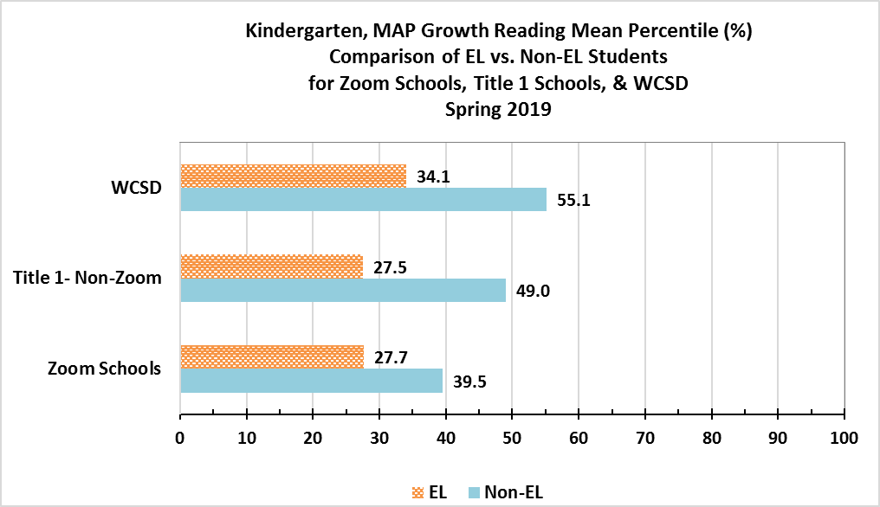

**Figure 2. Comparison of Kindergarten EL students vs. Non-EL students at Zoom Schools, other Title 1 Non-Zoom schools, & WCSD.**

**Grade 1-2 Results**

In SY 2019, the 40th percentile on the MAP Growth Reading assessment is Nevada’s Read by Grade 3 indicator for reading proficiency. Results for Spring 2019 MAP Growth Reading for Grade 1 and Grade 2 are shown in Table 5.

*Grade 1* results show Zoom schools (N=19) that met the 40th Percentile—Proficiency—as follows, (*note—data were not available for Mariposa Charter; totals may not equal 100% due to rounding):*

* 5% (1 school) had less than 20% of students that met proficiency
* 21% (4 schools) had 20-29% of students that met proficiency
* 32% (6 schools) had 30-39% of students that met proficiency
* 26% (5 schools) had 40-49% of students that met proficiency
* 16% (3 schools) had 50-59% of students that met proficiency
* Overall Zoom Schools had an average of 37% of *Grade 1* students that met reading proficiency compared to the Overall District at 54%

Grade 2 results show Zoom schools (N=19) that met the 40th Percentile—Proficiency—as follows, (*note—data were not available for Mariposa Charter; totals may not equal 100% due to rounding):*

* 0% (0 schools) had less than 20% of students that met proficiency
* 11% (2 schools) had 20-29% of students that met proficiency
* 32% (6 schools) had 30-39% of students that met proficiency
* 47% (9 schools) had 40-49% of students that met proficiency
* 11% (2 schools) had 50-59% of students that met proficiency
* Overall Zoom Schools had an average of 41% of *Grade 2* students that met proficiency compared to the Overall District at 55%

**Table 5. Percent (%) of Students Meeting 40th Percentile MAP Growth Reading, Spring 2019**

**Grade 1**

| Elementary School Name | Grade 1  Spring 2019  %Met 40th Percentile MAP Growth | Grade 2  Spring 2019  %Met 40th Percentile MAP Growth |
| --- | --- | --- |
| Anderson | 35.1 | 43.7 |
| Corbett | 30.4 | 49.2 |
| Duncan | 20.0 | 21.8 |
| Loder | 17.9 | 22.1 |
| Mathews | 55.8 | 55.7 |
| Veterans | 54.0 | 46.0 |
| Cannan | 32.5 | 33.3 |
| Sun Valley | 38.5 | 40.0 |
| Kate Smith | 23.6 | 43.1 |
| Lemelson | 38.3 | 38.2 |
| Lincoln Park | 40.5 | 40.9 |
| Allen | 46.8 | 39.3 |
| Mariposa Charter | Not Available | Not Available |
| Mitchell | 57.1 | 37.5 |
| Bennett | 25.5 | 38.7 |
| Greenbrae | 41.1 | 41.7 |
| Maxwell | 32.4 | 46.0 |
| Palmer | 44.9 | 54.4 |
| Risley | 27.9 | 37.5 |
| Smithridge | 46.4 | 43.8 |
| Overall Zoom ES% | **37.3** | 40.7 |
| Overall District ES% | 54.3 | 55.3 |

Figure 3 provides a comparison of EL students vs. Non-EL students in *Grade 1* at Zoom Schools, other Title 1 Non-Zoom schools, and WCSD. Results indicate that EL *Grade 1* students are performing slightly less (-1.8%) than other Title 1 schools, and less than (-7.1%) EL *Grade 1* students in the rest of the district.

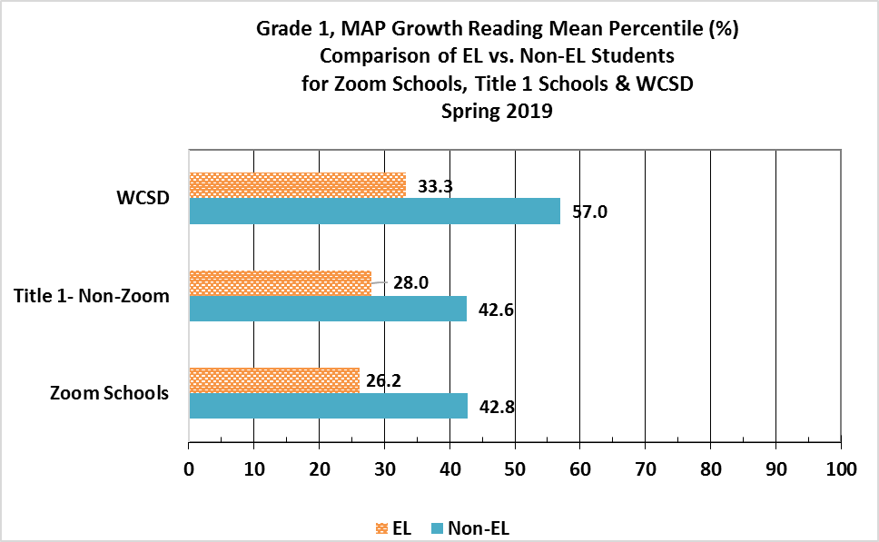

**Figure 3. Comparison of Grade 1 EL students vs. Non-EL students at Zoom Schools, other Title 1 Non-Zoom schools, & WCSD.**

Figure 4 provides a comparison of EL students vs. Non-EL students in *Grade 2* at Zoom Schools, other Title 1 Non-Zoom schools, and WCSD. Results indicate that EL *Grade 2* students are performing slightly better (+1.3%) than other Title 1 schools, and less than (-5.2%) EL *Grade 2* students in the rest of the district.

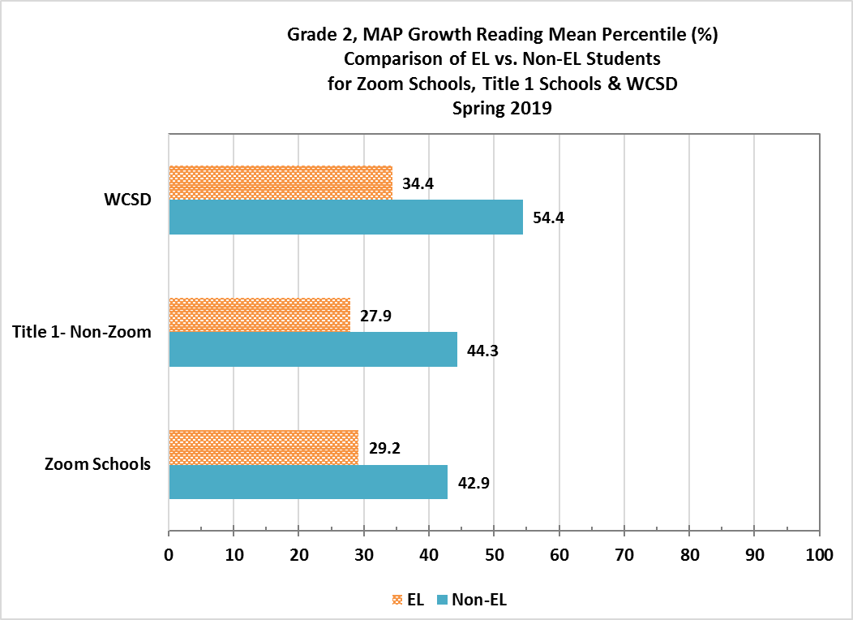

**Figure 4. Comparison of Grade 2 EL students vs. Non-EL students at Zoom Schools, other Title 1 Non-Zoom schools, & WCSD**

**Smarter Balanced Assessment Consortium (SBAC)-ELA**

SBAC is administered at the end of the school year and consists of two parts: a computer adaptive test and a performance task. As Zoom continues to focus on improving students’ English language arts/literacy, the reading proficiency of third graders as measured by SBAC will be a critical external accountability assessment tool used to monitor the overall effectiveness of the Zoom initiative.

**SBAC-ELA Zoom Elementary Schools Results: Grade 3**

Figure 5 details the percentage of Grade 3 students who met SBAC-ELA AL Level 3 and 4 Proficiency for the SY 2017, SY 2018, and SY 2019. Zoom students showed no change in proficiency—27% for both SY 2018 and SY 2019, with a slight increase (+3.0%) from SY 2017. Overall Zoom students had lower proficiency rates than similar Title 1 non-Zoom schools who experienced a slight decrease in Grade 3 proficiency from 2018 to 2019, 33% to 32%, respectively. WCSD decreased slightly from 45% to 44%, respectively, for SY 2018 and SY 2019.

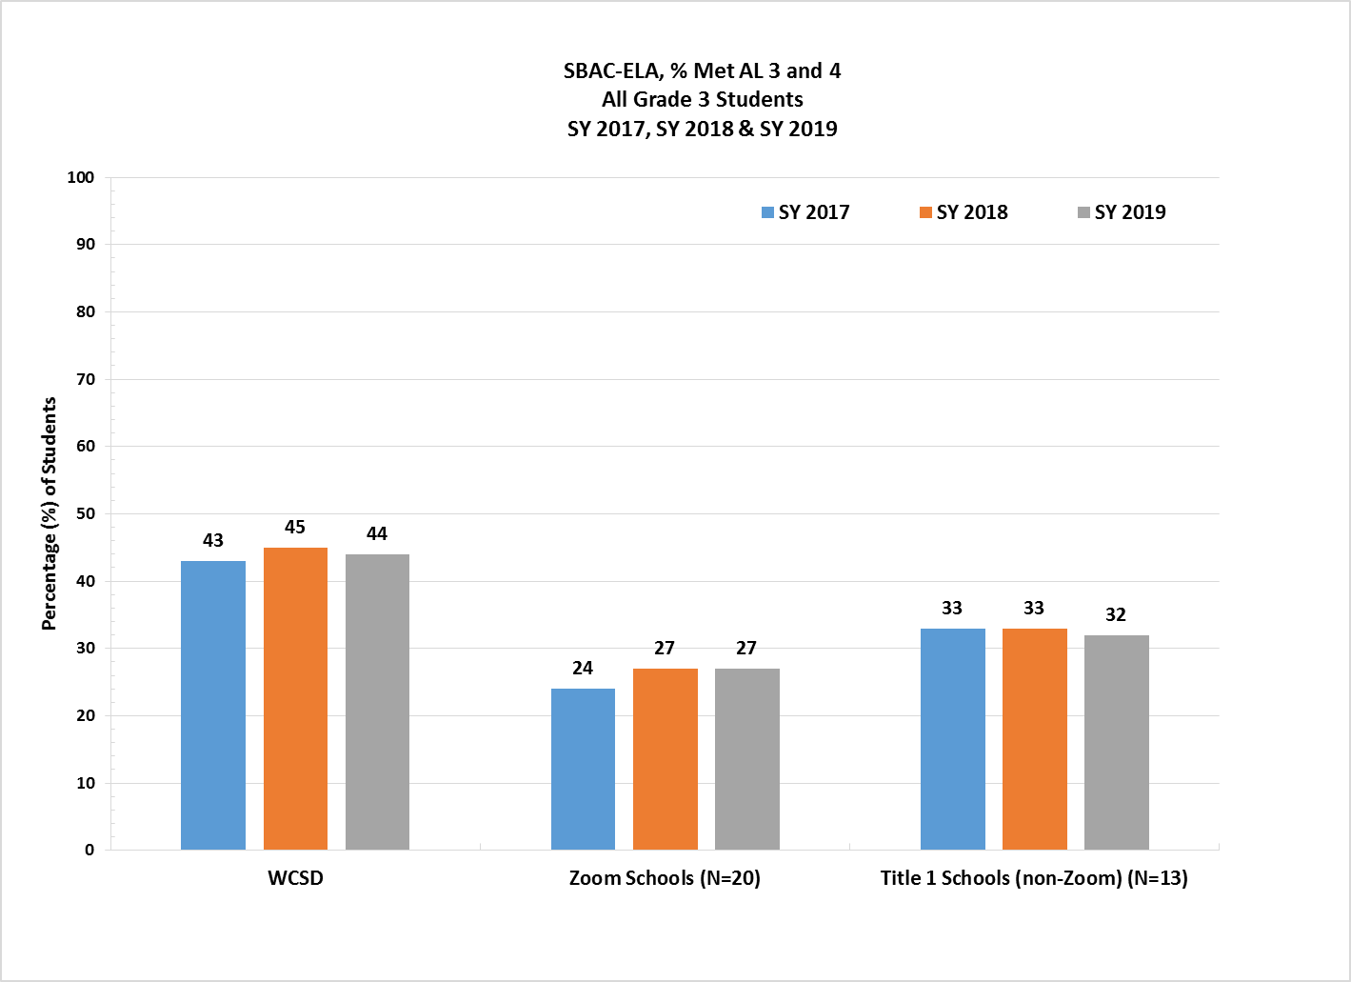

###### Figure 5. WCSD Zoom Elementary Schools, % SBAC - ELA - Grade 3 Overall Students

Figure 6 details the percentage of Grade 3 *EL students* who met SBAC-ELA AL Level 3 and 4 Proficiency for SY 2017, SY 2018, and SY 2019. EL students at Zoom schools showed a decrease in 3rd-grade ELA proficiency, from 17% to 14%, from SY 2018 and SY 2019. They had lower proficiency rates than other Title 1 non-Zoom schools that experienced an increase in proficiency from 19% to 21% during, from SY18 to SY 9. Grade 3 EL students in WCSD showed no change in proficiency between SY 2018 and SY 2019, staying at 18%.

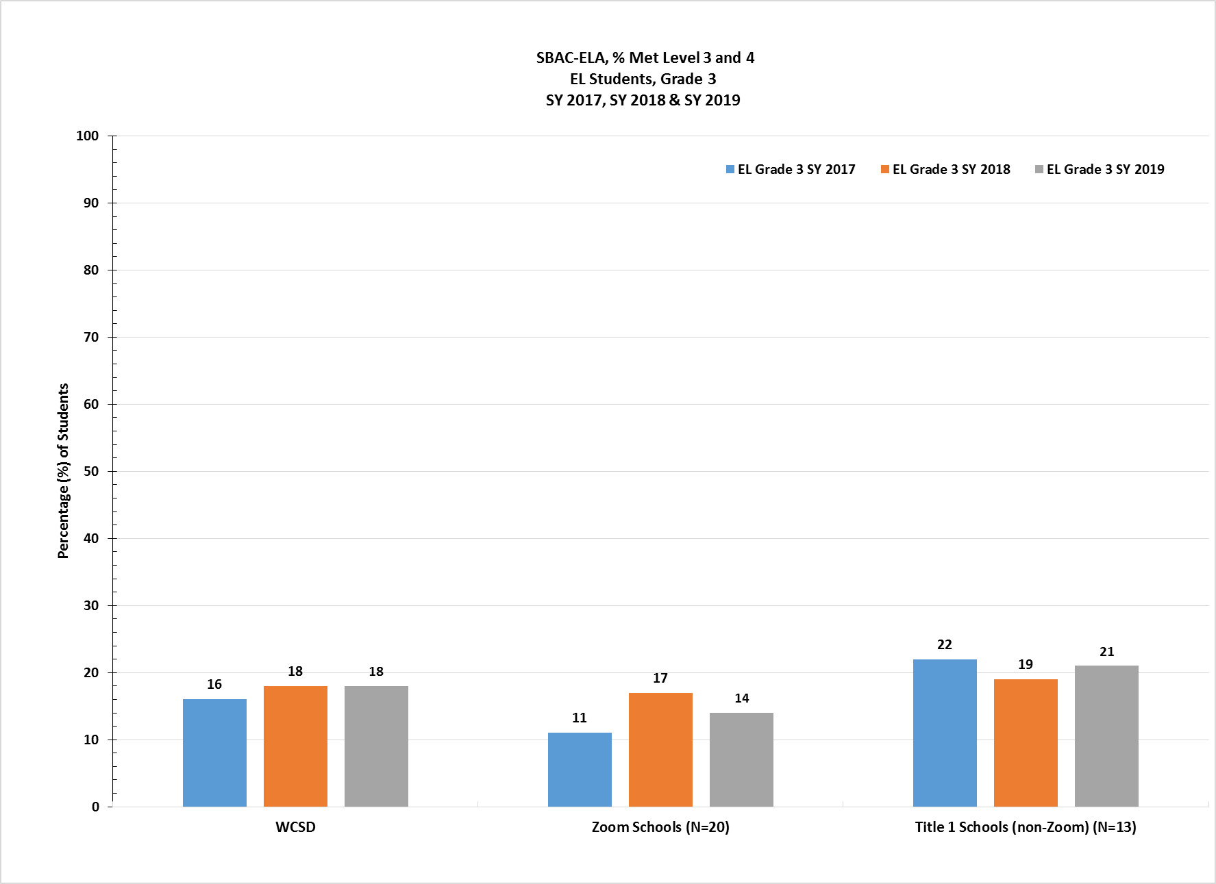

###### Figure 6. WCSD Zoom Elementary Schools, % SBAC–ELA Grade 3 EL Students

# ACCESS Exit Rates for English Learners (EL)—Zoom Elementary Schools

The ACCESS (Assessing Comprehension and Communication in English State-to-State for English Learners) is an annual summative assessment of the developing social and academic English language proficiency for EL students in kindergarten through 12th grade. In SY 2017, NDE revised Exit criteria for exiting EL students from services to 4.5 overall.

As shown in Figure 7, “WCSD Zoom Elementary Schools, EL % Exit Rates, SY 2017, SY 2018, and SY 2019”, results indicate WCSD Zoom schools showed a decrease of 3.1% in the total number of students exited between SY 2018 and SY 2019, from 14.9% to 11.8%. Zoom school students also exited at a lower rate than similar Title 1 non-Zoom schools in SY 2019—11.8% versus 13.0%, respectively.

The overall results for WCSD elementary schools indicate a decrease between SY 2018 and SY 2019, from 15.0% to 10.8%, and a 1.0% decrease compared to Zoom schools. WCSD is also 2.2% lower than similar Title 1 non-Zoom schools, 10.8% versus 13.0%, respectively. This translates into a total of 427 students exited from services at Zoom elementary schools, 157 students at similar Title 1 non-Zoom elementary schools, and 1,075 students overall in WCSD elementary schools in SY 2019.

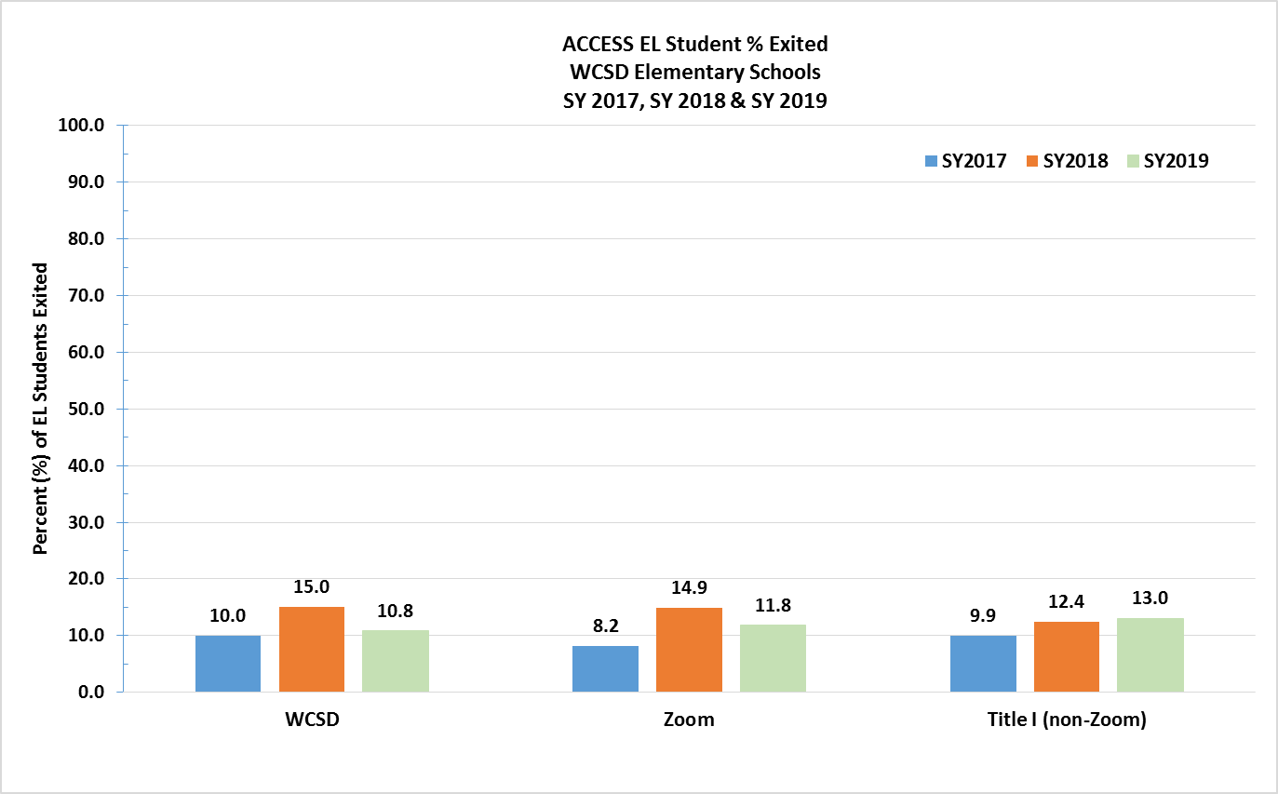

**Figure 7. Zoom Elementary Schools, EL % Exit Rates, SY 2017, SY 2018 & SY 2019**

# Nevada Growth Model (NGM) – English Learners’ AGP Performance:

# Elementary School Results

The Nevada Growth Model (NGM) measures student growth on state assessments compared to other students in the state with a similar score history. The Adequate Growth Percentile (AGP) on the ACCESS test is the Student Growth Percentile (SGP) an EL student needs to stay on track to reach a proficient level within five years or by grade 10.

NDE has established recommended performance levels and outcome indicators for Zoom funded schools. It is important to note that the AGP is only one of several measures used to evaluate progress of EL students in the state. NDE recommended the AGP performance target for Zoom schools be set at the 50th percentile, as shown in Table 6, for all elementary schools with sufficient N-count of EL students (adopted by SBE June 2016).

Table 7 shows the percentage of students at each WCSD Zoom elementary school who met AGP on the SY 2019 ACCESS exam, with 6 (30%) schools demonstrating positive growth; 3 (15%) schools with relatively flat growth; and 11 (55%) schools showing a decrease in AGP. However, a comparison between SY 2017 and SY 2019 shows that 15 (75%) of the Zoom elementary schools demonstrated an increase, and 5 (25%) demonstrated a decrease in AGP.

A comparison of star ratings between SY 2018 and SY 2019 show that 7 (35%) schools increased their rating, 11 (55%) maintained the same rating, and only 2 (10%) schools decreased by one star for the SY19.

**Table 6. Quartile Ranking, WCSD Zoom Elementary Schools, SY 2019**

| ELEM Schools: 343 | Half Midpoint 171.5 | Median 85.75 |  |
| --- | --- | --- | --- |
| *At or Below the*  *25th Percentile* | ***Below the***  ***50th Percentile*** | ***Above the***  ***50th Percentile*** | ***At or Above the***  ***75th Percentile*** |
| 0.00%≤ 39.99% | 40.00% ≥47.90% | **47.91%** ≥ 56.91% | 56.92.%≤ |

**Table 7. WCSD Zoom Elementary Schools, SY 2019**

**% EL Students Who Met WIDA Adequate Growth Percentile (AGP)**

| Original Funding Year | School Name  *(*Denotes*  *Corrective Action School)* | 2018 Star Rating | Trend | 2019 Star Rating | 2019 NSPF Total Index Score | 2017  % EL Met AGP | 2018  % EL Met AGP | 2019  % EL Met AGP | AGP Diff. from 2018 to 2019 |
| --- | --- | --- | --- | --- | --- | --- | --- | --- | --- |
| 2016 | Smithridge ES | 2 |  | 2 | 48.5 | 41.81 | 62.10 | 53.8 | -8.30 |
| 2015 | Lincoln Park ES | 2 |  | 2 | 27.0 | 52.00 | 60.44 | 44.4 | -16.04 |
| 2016 | Palmer ES | 2 |  | 3 | 52.5 | 47.42 | 57.89 | 55.4 | -2.49 |
| 2015 | Mitchell ES | 2 |  | 2 | 29.0 | 49.21 | 58.76 | 38.4 | -20.36 |
| 2016 | Greenbrae ES | 2 |  | 2 | 47.5 | 47.62 | 56.52 | 56.1 | -0.42 |
| 2016 | ***\**** Maxwell ES | 3 |  | 4 | 79.5 | 26.30 | 56.10 | 48.6 | -7.50 |
| 2013 | ***\**** Lemelson ES | 3 |  | 3 | 56.0 | 25.00 | 55.75 | 34.2 | -21.55 |
| 2016 | ***\**** Risley ES | 3 |  | 2 | 37.0 | 36.15 | 55.26 | 38.0 | -17.26 |
| 2016 | Bennett ES | 2 |  | 2 | 47.0 | 37.35 | 52.50 | 54.4 | 1.90 |
| 2013 | ***\**** Corbett ES | 2 |  | 4 | 69.5 | 36.53 | 51.61 | 56.2 | 4.59 |
| 2015 | Allen ES | 2 |  | 2 | 36.0 | 55.92 | 51.85 | 42.9 | -8.95 |
| 2013 | ***\**** Loder ES | 1 |  | 2 | 32.5 | 36.51 | 47.66 | 44.4 | -3.26 |
| 2015 | ***\**** Smith Kate ES | 2 |  | 2 | 47.5 | 35.00 | 46.67 | 58.8 | 12.13 |
| 2014 | ***\**** Sun Valley ES | 2 |  | 2 | 47.5 | 32.80 | 46.92 | 51.0 | 4.08 |
| 2013 | Anderson ES | 1 |  | 1 | 18.5 | 40.31 | 46.70 | 37.2 | -9.50 |
| 2014 | ***\**** Cannan ES | 1 |  | 2 | 28.5 | 30.00 | 45.39 | 45.7 | 0.31 |
| 2013 | Duncan ES | 1 |  | 2 | 32.0 | 46.43 | 42.95 | 43.2 | 0.25 |
| 2013 | Mathews ES | 1 |  | 2 | 29.0 | 41.26 | 40.69 | 51.0 | 10.31 |
| 2013 | ***\**** Veterans ES | 2 |  | 1 | 23.0 | 26.36 | 39.69 | 33.0 | -6.69 |
| 2015 | ***\**** Mariposa ES | 2 |  | 2 | 34.5 | 34.18 | 35.37 | 59.2 | 23.83 |

# Zoom Extended Day, Leveled Literacy Intervention (LLI) Model for Grades K-3

During the SY 2019, WCSD implemented an Extended Day (ED) program at 19 Zoom schools (Mariposa Charter did not participate). The Zoom schools adopted a model that was based on the Leveled Literacy Intervention (LLI) program kits developed by Fountas and Pinnell. The ED-LLI model was based on up to 21 weeks of intervention – four days per week, 30 minutes per session for each student identified as deficient, <40th Percentile on the MAP Growth Reading assessment.

Approximately three to six teachers per school (N=110) participated and each received a stipend for 4.5 hours per week to deliver the intervention (two hours/week), for planning, data management, participation in coaching (.5 hours/week), received two three-hour training sessions in LLI, and ongoing coaching and support from the Zoom facilitators. Note - some teachers did not complete the 21 weeks due to a variety of reasons - maternity leave, illness, etc. Each teacher selected a group of three to four students who were identified as deficient in reading to receive LLI instruction during the ED (before or after school). Not all schools had students from each grade (K-2) as each administrator was given the option to use discretion and may have chosen to only select teachers from Grade 1, etc., based on their school’s needs. Two schools elected to include some Grade 3 students in the ED-LLI program.

Teachers that participated in the extended day program received two half-day trainings, one additional half-day training for school site lead teachers, two coaching sessions (formal observation, a Teacher Practice Assessment (TPA), and debrief), and ongoing instructional and technical support with a coach (Modeling, PLC, Feedback, Problem solving, etc.). These additional professional learning activities were provided to help teachers implement LLI with fidelity. The *Estimated Cost-Per-Student* for Extended Day for SY 2019 is reported in Table 8.

**Table 8. WCSD Zoom Schools Extended Day Cost-Per-Student, SY 2019**

| School Year | $ Total Cost of Extended Day | Number of Students Served | $ Cost-Per-Student |
| --- | --- | --- | --- |
| 2018—2019 | $298,855 | 292 | $1,024 |

## Extended Day LLI Program Results: Grades 1-3

MAP Growth Reading data for Extended Day were analyzed and results indicated that the Leveled Literacy Intervention (LLI) support provided to students before/after school did not result in any significant improvement in reading proficiency scores between Fall 2018 and Spring 2019. Using the results, WCSD determined that it was not cost-effective to continue this particular Extended Day model, and it will not be implemented for the SY 2020.

As shown in Figure 8, EL students in Grade 1 performed as well as non-EL students, +8.0 vs +8.2 percentile change, although both groups were still below the proficiency level (40th Percentile) on MAP Growth Reading test scores.

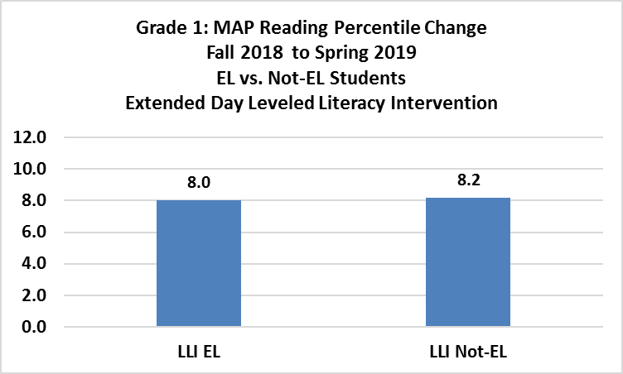

**Figure 8**. **MAP Reading Percentile Change, Fall 2018 to Spring 2019, EL vs. Non-EL Students, Extended Day Leveled Literacy Intervention (LLI), Grade 1**

As shown in Figure 9, EL students in Grade 2 performed slightly less non-EL students, +8.0 vs. +10.5 percentile change, although both groups were also still below the proficiency level (40th Percentile) on MAP Growth Reading test scores.

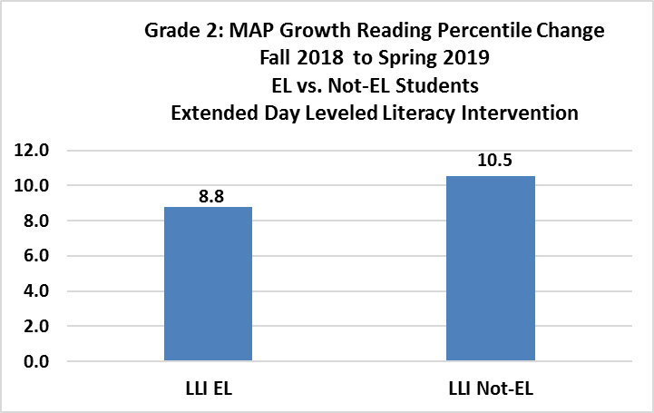

**Figure 9**. **MAP Reading Percentile Change, Fall 2018 to Spring 2019, EL vs. Non-EL Students, Extended Day Leveled Literacy Intervention (LLI), Grade 2**

As shown in Figure 10, EL students in Grade 3 performed slightly less non-EL students, +3.1 vs. +5.6 percentile change, although both groups were also still below the proficiency level (40th Percentile) on MAP Growth Reading test scores.

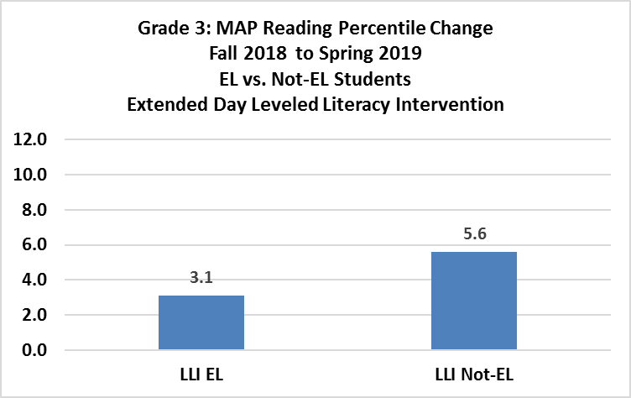

**Figure 10**. **MAP Reading Percentile Change, Fall 2018 to Spring 2019, EL vs. Non-EL Students, Extended Day Leveled Literacy Intervention (LLI), Grade 3**

Comparison of Overall Students vs. EL students, MAP percentiles, grade 1.  

**Figure 11. Group comparison charts (Overall Students vs. EL Students), Percentiles, Grade 1**

Comparison of Overall Students vs. EL students, MAP percentiles, grade 2.  

**Figure 12. Group comparison charts (Overall Students vs. EL Students), Percentiles, Grade 2**

Comparison of Overall Students vs. EL students, MAP percentiles, grade 3.  

**Figure 13. Group comparison charts (Overall Students vs. EL Students), Percentiles, Grade 3**

*NOTE: The third grade LLI and EL-LLI groups have small Ns (32 and 19, respectively).*

# Zoom Middle Schools - Program Assessment Results

Zoom middle schools—Dilworth, Sparks, Traner, and Vaughn—aim to create and foster a literacy environment to improve the culture with a focus on language and literacy development for all students. Specific Zoom goals include the following key components:

1. Reduce class sizes for EL students and provide English language literacy-based classes;
2. Direct instructional intervention to each EL student using data from assessments;
3. Intersession and/or Extended Day intervention activities; and
4. Other evidence-based programs and services approved by NDE.

Through responsible scheduling, middle schools continue to identify, and target students based on ACCESS/WIDA/ELPA assessment results, current coding as EL students, and other assessment data to drive responsible scheduling into classes taught by certified teachers with a TESL endorsement. For example, Traner Middle School students are scheduled into a daily 30-minute literacy enrichment class facilitated by a highly-qualified TESL endorsed teacher implementing the Achieve3000 Reading Program designed to address student enrichment and deficiencies using individual student assessment results. The goal of this program is to accelerate literacy and language gains for EL students through targeted instruction in general classrooms, as well as specialized classrooms.

Each middle school used Zoom funds to hire additional highly-qualified staff ranging from EL teacher assistants to highly qualified EL teachers as a strategy to reduce class sizes to be more responsive to EL students’ needs. For example, Traner Middle School used an additional certified/TESOL endorsed English Language Arts 7th-8th grade teacher to reduce class size and provide more intensive support for EL learners, while also strategically scheduling three teacher assistants for intervention support in classrooms with high EL student populations. Traner will continue to monitor the language assessment data based on a student reaching a level 5 or level 6 score on the ACCESS as an improvement measure for the Zoom initiative using EL exit rates calibrated to a four-year trend establishing a baseline to measure changes from SY 2016-2017 to SY 2018-2019.

In addition, each middle school provided Intersession(s) and/or Extended Day as an intervention to support the language and literacy development for EL students.

* Traner Middle School ran intersession during school breaks that focused on both math and ELA. This program had 24 students enrolled during winter intersession and 65 for spring intersession.
* Dilworth Middle School ran an after school extended studies program that provided additional instructional support and intervention to students identified through a combination of data review, teacher recommendation and parent recommendation. Students were place in the program for at least a unit of instruction (3-4 weeks) and often longer based on need. The program was fluid and served approximately 35 students each month.
* Sparks Middle School ran a jump start summer program for incoming 6th grade EL students. This program familiarized students with the middle school setting, schedule, curriculum and teachers.
* Vaughn Middle School ran an after-school tutoring program. This program allowed students access to additional instruction and intervention as needed.

**SBAC–ELA Zoom Middle Schools**

Figure 14 details the percentage of Grade 8 students overall who met SBAC-ELA AL Level 3 and 4 Proficiency for SY 2017, SY 2018, and SY 2019. Students at Zoom schools showed an increase from 32% to 35%, between SY 2018 and SY 2019, respectively. Zoom school proficiency rates were higher at 35% in SY 2019 than similar Title 1 non-Zoom schools who showed a decrease 44% vs. 31% between SY 2018 and SY 2019. Additionally, WCSD Grade 8-students performed higher with 50% proficiency vs. Zoom Schools at 35%, and Title 1 schools at 31% in SY 2019.

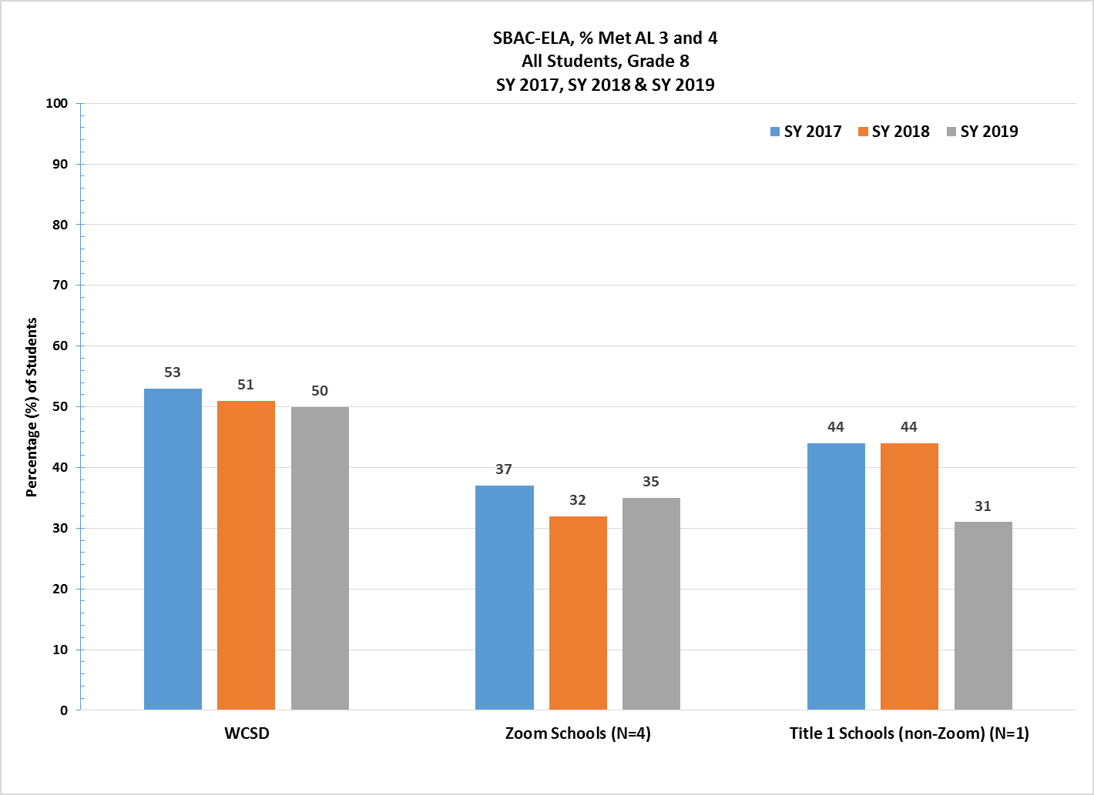

**Figure 14. WCSD Zoom Middle Schools, % SBAC—ELA Grade 8 Overall Students,**

**SY 2017, SY 2018 & SY 2019**

Figure 15 details the percentage of Grade 8 EL students who met SBAC-ELA AL Level 3 and 4 Proficiency for the SY 2017, SY 2018, and SY 2019. EL students at Zoom schools showed no change at 5%, between SY 2018 and SY 2019; and was the same as similar Title 1 non-Zoom schools who experienced a decrease from 8% to 5%, between SY 2018 and SY2019, respectively. WCSD Grade-8 EL students showed an increase from 5% to 7% between SY 2018 and SY 2019, and was higher than Zoom and similar Title 1 schools for SY 2019.

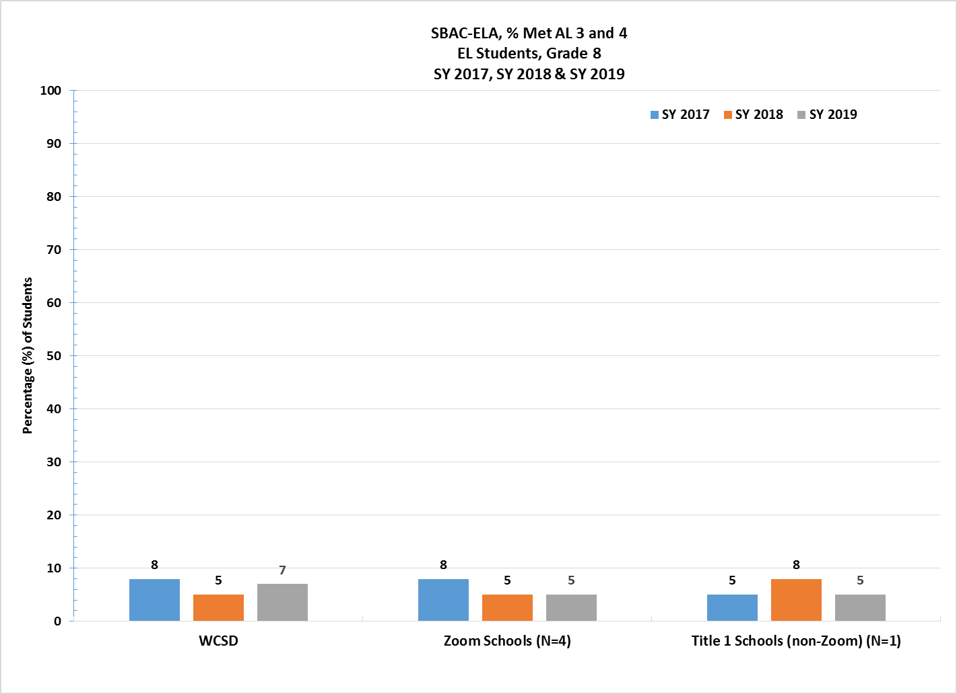

**Figure 15. WCSD Zoom Middle Schools, % SBAC – ELA Grade 8 EL Students,**

**SY 2017, SY 2018 & SY 2019**

# ACCESS Exit Rates for English Learners (EL)—Zoom Middle Schools

The ACCESS (Assessing Comprehension and Communication in English State-to-State for English Learners) is an annual summative assessment of the developing social and academic English language proficiency for EL students in Kindergarten through 12th grade. In SY 2017, NDE revised exit criteria for exiting EL students from services to 4.5 overall.

Figure 16, “WCSD Zoom Middle Schools, EL % Exit Rates, SY 2017, SY 2018 & SY 2019”,results for SY 2019 indicate that WCSD Zoom middle schools showed a slight increase in the total number of students exited between SY 2018 and SY 2019, from 6.3% to 6.7%. Additionally, Zoom middle schools exited at a higher rate than similar Title 1 non-Zoom schools did in SY 2019, 6.7% versus 2.5%. The results for WCSD middle schools overall show a very slight decrease of 0.1% between SY 2018 and SY 2019. This translates into a total of 52 students exited from services at Zoom middle schools, three students at similar Title 1 non-Zoom middle schools, and 103 students overall in WCSD middle school in SY 2019.

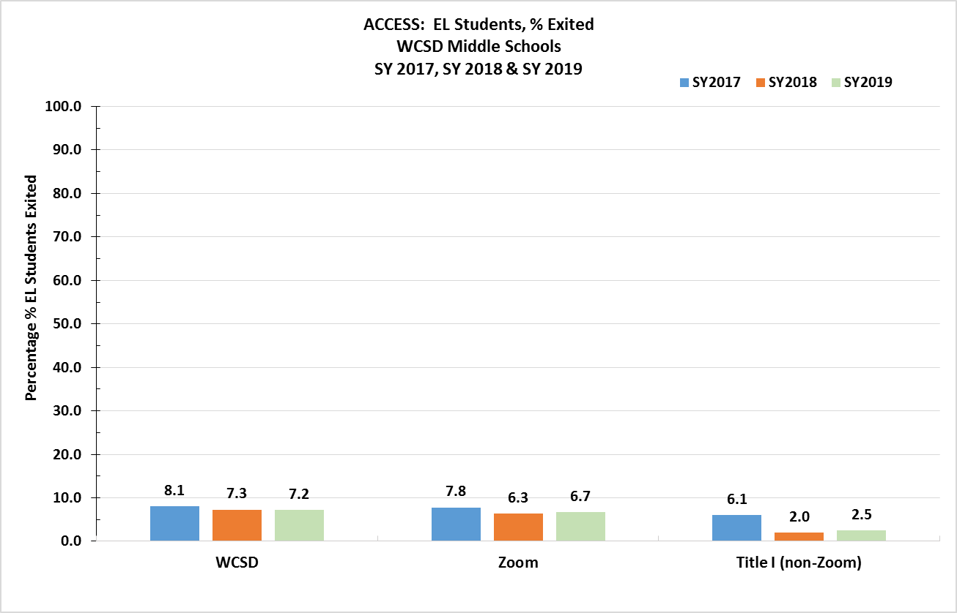

**Figure 16. Zoom Middle Schools, EL ACCESS %Exit Rates**

**SY 2017, SY 2018 & SY 2019**

###### Nevada Growth Model (NGM)—English Learners’ AGP Performance:

###### Middle School Results

The Nevada Growth Model (NGM) measures student growth on state assessments compared to other students in the state with a similar score history. The Adequate Growth Percentile (AGP) on the ACCESS test is the Student Growth Percentile (SGP) an EL student needs to stay on track to reach a proficient level within five years or by grade 10.

NDE recommended the AGP performance target for Zoom schools be set at the 50th percentile, as shown in Table 9, for all middle schools in the State with sufficient N-count of EL students (adopted by State Board of Education, June 2016). Table 10 shows the percentage of students at each WCSD Zoom Middle School who met AGP on the SY 2019 ACCESS assessment. Results in Table 8, “WCSD Zoom Middle Schools, SY2018-2019, % EL Students Who Met WIDA Adequate Growth Percentile (AGP),” show that all four Zoom middle schools showed a decline in AGP between SY 2018 and SY 2019. However, a comparison of SY 2017 and SY 2019 shows that two (50%) middle schools demonstrated an increase, and two (50%) demonstrated a decrease in AGP. A comparison of Star Ratings between SY 2018 and SY 2019 show two schools maintaining their rating, and two schools increasing their Star Rating by one star.

###### Table 9. Quartile Ranking, WCSD Zoom Middle Schools

###### SY 2019

| Middle Schools: 96 |  | Median 48.00 |  |
| --- | --- | --- | --- |
| *At or Below the*  *25th Percentile* | ***Below the***  ***50th Percentile*** | ***Above the***  ***50th Percentile*** | ***At or Above the***  ***75th Percentile*** |
| 0.00%≤23.99% | 24.00% ≥35.33% | 35.34% ≥ 48.10% | 48.11%≤ |

**Table 10. WCSD Zoom Middle Schools, SY 2019**

**% EL Students Who Met WIDA Adequate Growth Percentile (AGP)**

| Original Funding Year | School Name | 2018 Star Rating | Trend | 2019 Star Rating | 2019 NSPF Total Index Score | 2017  % EL Met AGP | 2018  % EL Met AGP | 2019  % EL Met AGP | AGP Diff. from 2018 to 2019 |
| --- | --- | --- | --- | --- | --- | --- | --- | --- | --- |
| 2016 | Sparks MS | 2 |  | 2 | 46.0 | 20.6 | 56.55 | 37.20 | -19.35 |
| 2016 | Dilworth MS | 2 |  | 2 | 41.0 | 18.9 | 48.84 | 26.80 | -22.04 |
| 2015 | Traner MS | 1 |  | 2 | 34.5 | 17.8 | 34.87 | 9.90 | -24.97 |
| 2016 | Vaughn MS | 1 |  | 2 | 32.0 | 19.2 | 23.13 | 13.40 | -9.73 |

**Corrective Action Schools**

The Nevada State Board of Education (SBE) has determined that the primary indicator for determining Zoom schools identified as “in need of improvement” is the percentage of English learners achieving AGP. NDE annually prepares a quartile ranking of all schools in Nevada with sufficient “n” based on WIDA language proficiency growth scores. **Zoom schools below the 25th percentile of Nevada schools for the ACCESS AGP are identified for improvement.** The Nevada SBE established statewide performance levels and outcome indicators for Zoom schools adopting ESSA Long-Term Goals and Measures for Interim Progress.

The Corrective Action Plan (CAP) outlines how each school will address the needs of EL students and improve the percentage of students achieving adequate growth toward English language acquisition. Each CAP plan includes the following priority-focused action statements, emphasizing evidence- based priorities with the greatest potential to address root causes:

* **Priority 1:** Teachers lack an understanding of the stages of development for language for a second language learner. As a result, teachers struggle to extend students’ language progress through the process of lesson plans that create the contexts for meaningful language use within the settings that integrate content and academic language learning. Building teacher capacity is important in the implementation of language rich strategies and activities that provide opportunities for EL students to make progress in the four domains of language.
* **Priority 2:** Teachers lack an understanding of formative and summative language assessment practices that are designed to advance the academic achievement and academic language development for culturally and linguistically diverse students. Building teacher capacity to use language data to backward plan for student language proficiency outcomes is also critical to gaining an understanding of language development practices that are crucial for second language learners to become proficient in English.
* **Priority 3:** Teachers at Zoom schools in WCSD lack an understanding of how to utilize the Interim Assessment Block (IAB) portion of the SBAC Interim package (or may choose to use School City interim assessment tools) as classroom instructional activities. Teachers will use the IABs throughout the school year to focus on a set of ELA and Mathematics concepts as an instructional tool during the appropriate unit of study. Teachers will be able to provide a practice opportunity for students as they monitor and facilitate classroom discussions of items that align to the Smarter Summative Assessment Blueprint. This is critical in aligning the language development to practice opportunities that prepare students for the types of items found on SBAC, so that ELs increase achievement not only on formative language assessment(s) but state mandated assessments.

# Professional Learning

Zoom Professional Learning (PL) goals are to design professional learning systems to support educators in implementing effective instructional practices as part of a comprehensive literacy day to support and accelerate students’ reading growth, thus developing proficient readers with the capacity to comprehend texts across a range of types and disciplines. As part of WCSD’s Read by Grade Three program, this PL around T1 literacy is provided to all elementary schools. At the secondary level, this PL is embedded in secondary content PL.

In additional Zoom school PL focuses on increasing educators’ capacity to deliver content embedded language instruction that is targeted to the needs of individual learners and aims to improve language proficiency across all 4 domains of language. During SY 2019, WCSD purchased ELLevation and began the very early stages of professional learning. This tool will provide educators with access to data and resources that will help them incorporate and customize language learning strategies into lessons. The expansion of PL and use of ELLevation is planned for the 2019-2021 biennium.

As shown in Table 11, various topics were presented to educators throughout the District. The total number of participants receiving PL during the SY 2019 included the Learning Strategists from all Zoom schools, as well as, teachers, administrators, and other educators. Please note, the available data do not disaggregate by specific schools, but represent the District as a whole.

Participant ratings for all professional learning sessions listed were *Agree-Strongly Agree* across all components presented, were well-received by all participants.

**Table 11. Professional Learning Topics for SY 2019**

| **Topic** | **Phonemic**  **Awareness** | **Phonics &**  **Word Study** | **Vocabulary** | **Fluency** | **Comprehension** | **Assessment** | **K-4 Educators**  **(N)** | **Learning Strategist**  **(N)** | **Administrator**  **(N)** | **Other**  **(N)** |
| --- | --- | --- | --- | --- | --- | --- | --- | --- | --- | --- |
| Foundational Skills | X | X |  | X |  |  |  | 60 |  |  |
| Components of Structured Phonics | X | X |  |  |  |  | 159 | 42 | 52 | 15 |
| Leveled Literacy Intervention Grades K-2 | X | X | X | X | X | X | 56 | 11 |  |  |
| Leveled Literacy Intervention Grade 3 | X | X | X | X | X | X | 59 | 5 |  | 3 |
| Phonics First | X | X |  |  |  |  | 61 | 4 |  |  |
| Building Knowledge with Complex Text |  |  | X |  | X |  |  | 55 |  |  |
| Scaffolding Complex Text with Syntax |  |  | X |  | X |  |  | 56 |  |  |
| New Benchmark ELA Adoption Materials | X | X | X | X | X | X | 4 | 52 | 71 | 16 |
| Learning Strategist Bootcamp |  | X |  |  | X |  | 17 | 15 |  |  |
| Learning Strategist Institute – ELA Standards/Shifts | X | X | X | X | X |  | 13 | 65 |  |  |
| Learning Strategist Institute – Foundational Skills | X | X |  |  |  |  | 13 | 65 |  |  |
| Learning Strategist Institute – Fluency, Complex Text |  |  | X | X | X |  | 10 | 65 |  |  |
| Learning Strategist Institute – Vocabulary, Interactive Read Alouds |  |  | X |  | X |  | 12 | 65 |  |  |
| Learning Strategist Institute – AimsWeb, Dyslexia Screening, MTSS, MAP |  |  |  |  |  | X | 12 | 65 |  |  |
| Learning Strategist Institute – Literacy Block Structure | X | X | X | X | X |  | 12 | 65 |  |  |
| Guided Reading-  *Zoom Schools Only* |  |  |  |  |  |  |  | 53 |  |  |
| Running Records – *Zoom Schools Only* |  |  |  |  |  |  |  | 12 |  |  |

# Recommendations

The Zoom School initiative has enabled WCSD to reconsider and restructure thinking and practice regarding the appropriation of new models for growth, as well as modes of teaching and learning to support EL students. The major investments must focus on strengthening the collective capacity of teachers, school administrators, and district leaders to create conditions for improved instructional practice and student achievement.

WCSD Zoom schools will maintain uninterrupted programming and services as a result of legislators’ decision to *continue* Zoom funding for the next biennium, 2019-2021. The program impact will allow sustained support through SY 2020 and SY 2021 for all 24 Zoom schools. Zoom funding will provide WCSD the resources and opportunity to continue critical programming.

WCSD recommends continued funding for the following:

1. Certified teachers and classified staff in order to reduce class size and provide students with the high-quality, targeted EL and literacy instruction that they need.
2. Professional learning for teachers to ensure that EL, literacy and intervention instruction is delivered to the highest degree possible.
3. Intersession and/or extended day programs to provide students additional instructional time outside of the regular school day and to work with existing afterschool programs such as 21st Century Community Learning Centers in order to maximize efficiency (teachers’ availability) and not compete with other after school programs to ensure student attendance.
4. Pre-K programs to strengthen kindergarten readiness.
5. Critical resources to enhance EL, literacy and intervention instruction and programs (e.g. Reading Skills Centers, ELLevation).

Finally, WCSD recommends the elimination of the 5%spending cap. This would allow all Zoom-funded LEAs the flexibility and ability to better support schools through high-quality teacher professional development opportunities. LEAs would also be able to explore potential strategy development of effective teacher recruitment and retention incentives, and potential increases in family engagement activities leading to successful language acquisition growth for all Zoom school students.